Drama in the Classroom

By Reginald Hart



Warm-Up Exercises, Theater Games and Staging Small Skits
Some good starting points for using drama in the classroom are exercises, theater games and skits. After many repetitions of these short theater games and skits, students will be more confident that they can put on a big play. Drama is a great help for shy students, helping them learn to work in a group and overcome their fears. Some students will want to organize and lead, and sometimes this is fine, but some students became too bossy. The teacher should always be on-hand to settle disputes and promote a team effort. On occasion, a student’s negative feelings will show itself in drama. This may produce a positive result in the long term. Drama is a safe way for people to work out anger, frustration and fears.

Warm up exercises

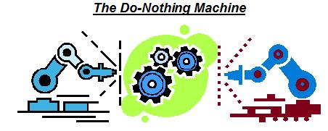

This activity promotes harmony and imagination. Students work in groups of three and create a machine.
To make the machine: The first student goes to the middle of an empty space in the room and begins a simple, but repetitive movement such as bending the arm at the elbow, moving one leg, or bobbing the head. At the same time, the student makes a nonsense sound or something onomatopoetic such as bang, clank, bonk, buzz, crunch, growl, screech, squish, thud, thump, zing, zoom, crash, ka-ching, or any sound the student desires.
Then, each member of the group, one at a time will enter and do a different, yet harmonic, repetitive movement and sound. In other words the students work as a unit to create a unique, sometimes comical machine that does nothing: The Do-Nothing Machine.

- Divide the class into groups of three and they can take turns being the audience.
- The audience is as important as the actors.
- Student A goes to the middle of an empty space and does a repetitive movement and sound.
- Then Student B and Student C, one at a time, should join in, with each doing a repetitive sound and reoccurring movement.
- Students should work closely together; interact, but not touch each other as they create the machine.

In addition to being creative, the activity is great physical exercise. It promotes teamwork as well as utilizing individual strengths. There is no failure. Every student enjoys total freedom to act and interact in the activity.
This activity helps students to think visually and three-dimensionally and gets them using their bodies. The audience is always delighted.

Name that Face



Have the students sit in circles. One large circle if the area allows. If not, divide the students into groups of 4 – 6.

Have each student say their name three times.
1. In an angry voice.
2. In a confused voice.
3. In a sad voice.

The students should use facial expressions and tone of voice to indicate to the other
students which emotion is being expressed. Other students call out the name of the
emotion. At the end, the teacher tells the students that they have been acting!!!
_____________________________________________________________________________
Just say No!!!

This warm-up activity is similar to Name that Face, but done in groups of two.

A pair of students practice saying "please" and "no" in three different ways. They should feel free
to play around with their voices and facial expressions. It is also helpful to be able to stand up
and use full body movement: body language. After a few repetitions, the students exchange
roles. Working with a partner helps introverted students overcome their shyness.

Tickle-Trunk Skit

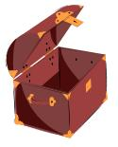

Bring in different objects -- hats, sunglasses, old kitchen utensils, discarded badminton rackets,
car keys, an old camera, coats, gloves etc. Put the items into a cardboard box or a large, opaque
plastic container.

1. The students fish around without looking and pick an item, or the teacher hands out the items.
2. The students then have 4-5 minutes to come up with a short skit using the items.
3. Every item has to have a meaning in the skit and obviously, each student has a part.
4. Groups of three or four can be working in different areas of the room simultaneously.
5. After a few minutes, each group goes to the front to perform their skit.

*Teacher can decide the skit order by lottery or ask for volunteers.

ROBOTS ON PARADE

...........
In this activity students parade in a large circle around the room, each one a different robot with its own unique movement and sound.

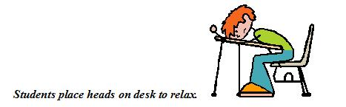

Turn down the lights and tell the students to think of themselves as relaxed as limp spaghetti. They should make up a peaceful place --lying on a floating raft or at the beach or on a soft patch of grass; somewhere they love to be.
Do this for exactly 3 minutes. Then the students share where they'd been and what they'd felt or imagined. Some may chose not to tell. It is a voluntary exercise.

Staging Large Dramas



Staging a large drama using groups of 10 – 12 or larger requires more time and practice. Props and scenery can be non-existent, simple or sometimes incredibly complicated and detailed. For this type of production the best results will come from older students in grades 4 – 6 or higher. Reading ability is essential. Additionally, it is advisable to have the students be familiar with the plot of the drama prior to encountering a script. The teacher can use various methods to introduce the story-line: reading a story-book, watching a video, using a Power-point presentation or even making it a homework assignment.

First things first
There are numerous decisions to make before beginning a large scale production:
- What size of staging area can we use?
- How many students will be involved?
- What level of English skills do the students have? What grammar points might be practiced within the dialogue?
- Should we write an original script or use one previously written? Should we adapt a folk tale or a local legend? Should we search the library or browse the internet for play scripts?

Once a script is chosen assemble the students and have them sit in a circle or around a table. Then have a mock-reading of the script involving as many students as possible. If the script is short read it a couple of times using different students. After that, decide on the various roles for the students. Some students will be actors and some will be involved with off-stage production.
Actors: Although the actors are the ones in the spotlight, they should be humble and follow the advice of the director. Try to avoid having the same students acting in every stage production. If time permits, audtitions could be held for the lead roles.
Off-Stage Production Crew
Student Director: It is a good idea for one of the students to take on the leadership role of ‘director’. The director leads all aspects of the practice; deciding the location of props, the positions of the actors, and the other large decisions involved with staging a large-scale production. The director envisions the play from the audience’s perspective.
Stage Manager: Assists the director by arranging backdrops and stage props and by managing the stage hands.
Stage Hands: Anyone can be a stage hand. Stage hands help move props, open and close curtains, help with costuming, lighting, sound and anything else required to make the play a smashing success.
Blocking

Stage Directions are given by the Director during the rehearsal. This is known as blocking. "Blocking" the show is very important. All the actors should be as visible as possible to the audience. Try to avoid having one actor standing directly in front of another. The actors should know the various motions on the stage and know how and when to enter and exit -- and where to be at all times on the stage. The actors are given directions that help the scene to progress and facilitate the movement of the play. The various movements of the actors help to convey whatever emotion/effect the Director is going for in that scene.
The diagram below explains the Director's instructions. On stage your viewpoint is reversed from that of the audience, and the director and actors and all involved in the production must learn to understand this viewpoint.

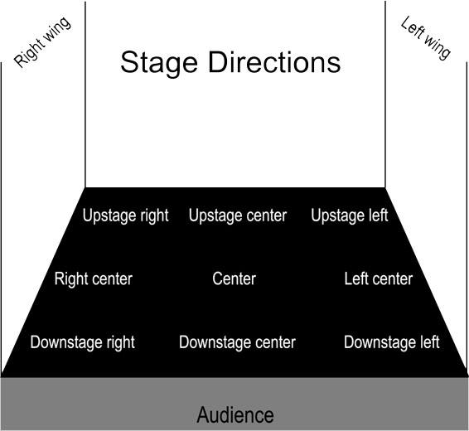

Stage Diagram courtesy: http://www.musical-theater-kids.com/stage-directions.html

The script should have directions for the actors (enter stage right, exit stage left, stand downstage center, sit left center and so on). The director uses these blocking directions to aid the flow of the action and help all the actors to move harmoniously around the stage.
Another part of blocking is to position the actors so that, when they move, they have their backs to the audience as little as possible. Part of that idea dates back to pre-microphone days. Actors are heard better when they face the audience rather than when they have their heads facing the backdrop or the curtains. Plus, the human face is more expressive than the back of the head.
Finally, actors have to practice not looking at the audience or acknowledging their presence while playing to them, thus establishing an invisible Fourth Wall. This helps establish a suspension of disbelief, giving the audience a sense that they are witnessing reality and not simply watching an amateur production. Correct blocking assists in maintaining that Fourth Wall whose line the actors should not normally cross.
Of course there are many steps to take in a large-scale production. Teachers and students should work together to create a successful performance. The attention spent in the planning and practice stages are the most important. Remember to put the effort up front and reap the rewards later.
For Further Drama Study:

http://www.musical-theater-kids.com/index.html
http://www.indiana.edu/~reading/ieo/bibs/rdr-thea.html
http://plays.about.com/od/plays/tp/freeplays.htm
http://www.proteacher.net

